|  |
| --- |
|  |
|  |

|  |  |  |  |  |  |
| --- | --- | --- | --- | --- | --- |
| REVISION HISTORY | | | | | |
| Ver. | Description of Change | Author | Date | Approved | |
| Name | Effective Date |
| 1.0 | Initial status | [Kiryl Bucha](mailto:Kiryl_Bucha@epam.com) | 12-JAN-2012 |  |  |
| 2.0 | Updated in accordance with renewed content | [Elias Nema](mailto:Elias_Nema@epam.com) | 20-JAN-2014 |  |  |
| 3.0 | Report | Aksana Kuratnik | 06-DEC-2017 |  |  |

Contents

1. Create Packages for Reload Dimension from SA_* 3

2. Task Results 3

# Create packages to load dimensions from source to staging (3NF) layer

* Create all required dim objects on ST Layer (T_...).

On the 3NF layer necessary tables and sequences were created.

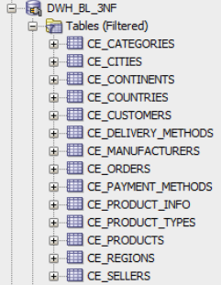 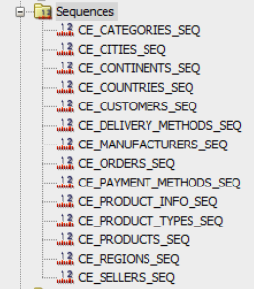

3NF Scheme:

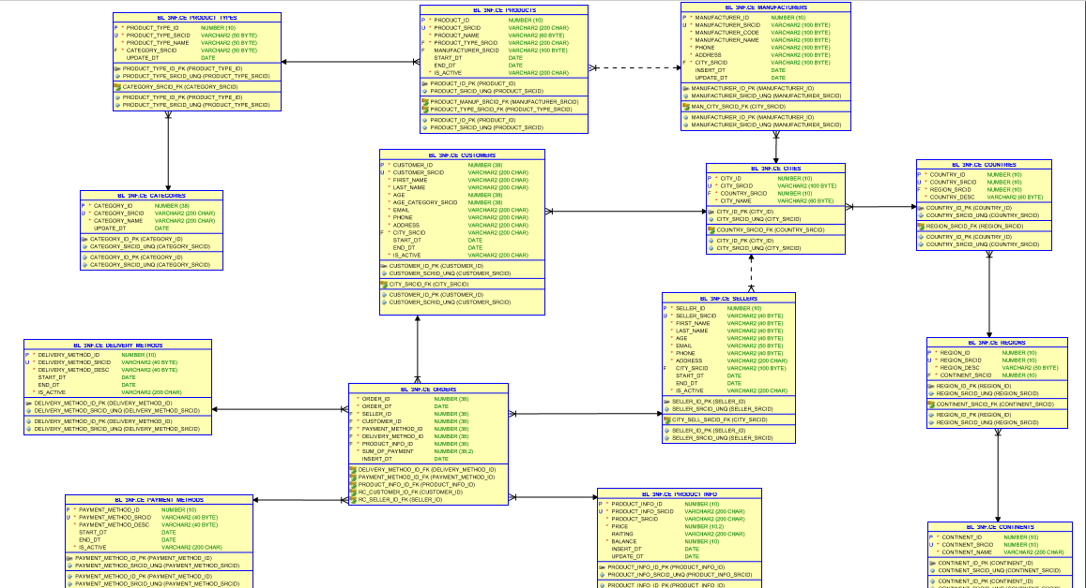

* Grant all required privileges to ST_CL (Cleansing Layer).

All privileges on tables and sequences from 3NF-layer were granted to BL_CL-layer.

GRANT INSERT ON BL_3NF.CE_CONTINENTS TO BL_CL_1ST;

GRANT SELECT ON BL_3NF.CE_CONTINENTS TO BL_CL_1ST;

GRANT UPDATE ON BL_3NF.CE_CONTINENTS TO BL_CL_1ST;

GRANT SELECT ON BL_3NF.CE_CONTINENTS_SEQ TO BL_CL_1ST;

GRANT INSERT ON BL_3NF.CE_REGIONS TO BL_CL_1ST;

GRANT SELECT ON BL_3NF.CE_REGIONS TO BL_CL_1ST;

GRANT UPDATE ON BL_3NF.CE_REGIONS TO BL_CL_1ST;

GRANT SELECT ON BL_3NF.CE_REGIONS_SEQ TO BL_CL_1ST;

GRANT INSERT ON BL_3NF.CE_COUNTRIES TO BL_CL_1ST;

GRANT SELECT ON BL_3NF.CE_COUNTRIES TO BL_CL_1ST;

GRANT UPDATE ON BL_3NF.CE_COUNTRIES TO BL_CL_1ST;

GRANT SELECT ON BL_3NF.CE_COUNTRIES_SEQ TO BL_CL_1ST;

GRANT INSERT ON BL_3NF.CE_CITIES TO BL_CL_1ST;

GRANT SELECT ON BL_3NF.CE_CITIES TO BL_CL_1ST;

GRANT UPDATE ON BL_3NF.CE_CITIES TO BL_CL_1ST;

GRANT SELECT ON BL_3NF.CE_CITIES_SEQ TO BL_CL_1ST;

GRANT INSERT ON BL_3NF.CE_PRODUCT_TYPES TO BL_CL_1ST;

GRANT SELECT ON BL_3NF.CE_PRODUCT_TYPES TO BL_CL_1ST;

GRANT UPDATE ON BL_3NF.CE_PRODUCT_TYPES TO BL_CL_1ST;

GRANT SELECT ON BL_3NF.CE_PRODUCT_TYPES_SEQ TO BL_CL_1ST;

GRANT INSERT ON BL_3NF.CE_PRODUCT_INFO TO BL_CL_1ST;

GRANT SELECT ON BL_3NF.CE_PRODUCT_INFO TO BL_CL_1ST;

GRANT UPDATE ON BL_3NF.CE_PRODUCT_INFO TO BL_CL_1ST;

GRANT SELECT ON BL_3NF.CE_PRODUCT_INFO_SEQ TO BL_CL_1ST;

GRANT INSERT ON BL_3NF.CE_CUSTOMERS TO BL_CL_1ST;

GRANT SELECT ON BL_3NF.CE_CUSTOMERS TO BL_CL_1ST;

GRANT UPDATE ON BL_3NF.CE_CUSTOMERS TO BL_CL_1ST;

GRANT SELECT ON BL_3NF.CE_CUSTOMERS_SEQ TO BL_CL_1ST;

GRANT INSERT ON BL_3NF.CE_MANUFACTURERS TO BL_CL_1ST;

GRANT SELECT ON BL_3NF.CE_MANUFACTURERS TO BL_CL_1ST;

GRANT UPDATE ON BL_3NF.CE_MANUFACTURERS TO BL_CL_1ST;

GRANT SELECT ON BL_3NF.CE_MANUFACTURERS_SEQ TO BL_CL_1ST;

GRANT INSERT ON BL_3NF.CE_SELLERS TO BL_CL_1ST;

GRANT SELECT ON BL_3NF.CE_SELLERS TO BL_CL_1ST;

GRANT UPDATE ON BL_3NF.CE_SELLERS TO BL_CL_1ST;

GRANT SELECT ON BL_3NF.CE_SELLERS_SEQ TO BL_CL_1ST;

GRANT INSERT ON BL_3NF.CE_PAYMENT_METHODS TO BL_CL_1ST;

GRANT SELECT ON BL_3NF.CE_PAYMENT_METHODS TO BL_CL_1ST;

GRANT UPDATE ON BL_3NF.CE_PAYMENT_METHODS TO BL_CL_1ST;

GRANT SELECT ON BL_3NF.CE_PAYMENT_METHODS_SEQ TO BL_CL_1ST;

GRANT INSERT ON BL_3NF.CE_DELIVERY_METHODS TO BL_CL_1ST;

GRANT SELECT ON BL_3NF.CE_DELIVERY_METHODS TO BL_CL_1ST;

GRANT UPDATE ON BL_3NF.CE_DELIVERY_METHODS TO BL_CL_1ST;

GRANT SELECT ON BL_3NF.CE_DELIVERY_METHODS_SEQ TO BL_CL_1ST;

GRANT INSERT ON BL_3NF.CE_ORDERS TO BL_CL_1ST;

GRANT SELECT ON BL_3NF.CE_ORDERS TO BL_CL_1ST;

GRANT UPDATE ON BL_3NF.CE_ORDERS TO BL_CL_1ST;

GRANT SELECT ON BL_3NF.CE_ORDERS_SEQ TO BL_CL_1ST;

GRANT INSERT ON BL_3NF.CE_PRODUCTS TO BL_CL_1ST;

GRANT SELECT ON BL_3NF.CE_PRODUCTS TO BL_CL_1ST;

GRANT UPDATE ON BL_3NF.CE_PRODUCTSTO BL_CL_1ST;

GRANT SELECT ON BL_3NF.CE_PRODUCTS_SEQ TO BL_CL_1ST;

GRANT INSERT ON BL_3NF.CE_CATEGORIES TO BL_CL_1ST;

GRANT SELECT ON BL_3NF.CE_CATEGORIES TO BL_CL_1ST;

GRANT UPDATE ON BL_3NF.CE_CATEGORIES TO BL_CL_1ST;

GRANT SELECT ON BL_3NF.CE_CATEGORIES_SEQ TO BL_CL_1ST;

* Create packages to load dim data (one package = one dimension) on ST_CL.

**CE_CONTINENTS:**

--PKG_INSERT_CONTINENTS.

CREATE OR REPLACE PACKAGE pkg_etl_insert_continents

AUTHID CURRENT_USER

AS

PROCEDURE merge_ce_continents;

END pkg_etl_insert_continents;

/

CREATE OR REPLACE PACKAGE BODY pkg_etl_insert_continents

AS

PROCEDURE merge_ce_continents

IS

BEGIN

MERGE INTO bl_3nf.ce_continents t USING

( SELECT continent_id,

continent_name

FROM cls_continents

MINUS

SELECT continent_srcid AS continent_id,

continent_name

FROM bl_3nf.ce_continents

) c ON ( c.continent_id = t.continent_srcid

AND c.continent_name = t.continent_name)

WHEN NOT matched THEN

INSERT

(

continent_id,

continent_srcid,

continent_name

)

VALUES

(

bl_3nf.ce_continents_seq.NEXTVAL,

c.continent_id,

c.continent_name

) ;

COMMIT;

EXCEPTION

WHEN OTHERS THEN

RAISE;

END merge_ce_continents;

END pkg_etl_insert_continents;

/

Implementation of the pkg_etl_insert_continents:

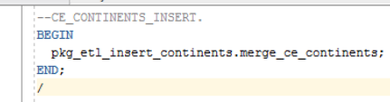

The result of insert:

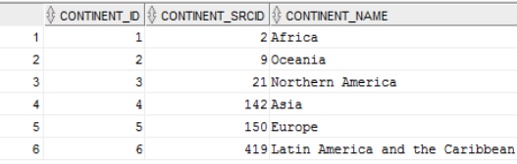

**CE_REGIONS:**

--PKG_INSERT_REGIONS.

CREATE OR REPLACE PACKAGE pkg_etl_insert_regions

AUTHID CURRENT_USER

AS

PROCEDURE merge_ce_regions;

END pkg_etl_insert_regions;

/

CREATE OR REPLACE PACKAGE BODY pkg_etl_insert_regions

AS

PROCEDURE merge_ce_regions

IS

BEGIN

MERGE INTO bl_3nf.ce_regions t USING

( SELECT continent_id,

region_id,

region_desc

FROM cls_regions

MINUS

SELECT continent_srcid,

region_srcid AS region_id,

region_desc

FROM bl_3nf.ce_regions

) c ON ( c.region_id = t.region_srcid

AND c.continent_id = t.continent_srcid

AND c.region_desc = t.region_desc)

WHEN NOT matched THEN

INSERT

(

region_ID ,

region_srcid ,

continent_srcid,

region_desc

)

VALUES

(

bl_3nf.ce_regions_seq.NEXTVAL,

c.region_id,

c.continent_id,

c.region_desc

) ;

COMMIT;

EXCEPTION

WHEN OTHERS THEN

RAISE;

END merge_ce_regions;

END pkg_etl_insert_regions;

/

Implementation of the pkg_etl_insert_regions:

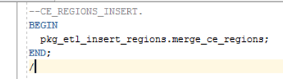

The result of insert:

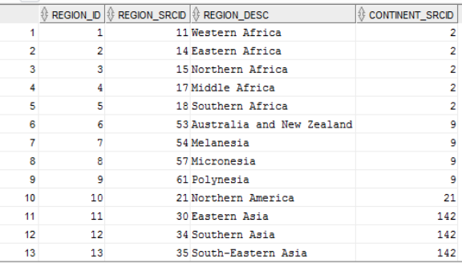

**CE_COUNTRIES:**

--PKG_INSERT_COUNTRIES.

CREATE OR REPLACE PACKAGE pkg_etl_insert_countries

AUTHID CURRENT_USER

AS

PROCEDURE merge_ce_countries;

END pkg_etl_insert_countries;

/

CREATE OR REPLACE PACKAGE BODY pkg_etl_insert_countries

AS

PROCEDURE merge_ce_countries

IS

BEGIN

MERGE INTO bl_3nf.ce_countries t USING

( SELECT region_id,

country_id,

country_desc

FROM cls_countries

MINUS

SELECT region_srcid,

country_srcid AS country_id,

country_desc

FROM bl_3nf.ce_countries

) c ON ( c.country_id = t.country_srcid

AND c.region_id = t.region_srcid

AND c.country_desc = t.country_desc)

WHEN NOT matched THEN

INSERT

(

country_ID ,

country_SRCID ,

region_srcid,

country_desc

)

VALUES

(

bl_3nf.ce_countries_seq.NEXTVAL,

c.country_id,

c.region_id,

c.country_desc

) ;

COMMIT;

EXCEPTION

WHEN OTHERS THEN

RAISE;

END merge_ce_countries;

END pkg_etl_insert_countries;

/

Implementation of the pkg_etl_insert_countries:

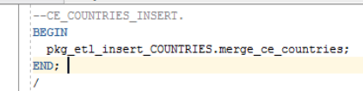

The result of the insert:

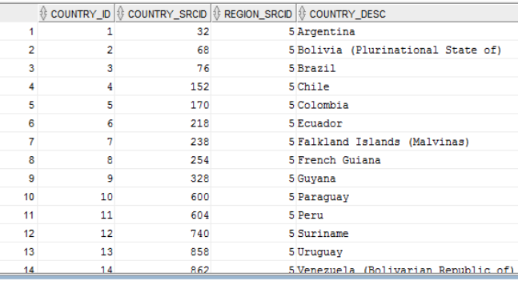

**CE_CITIES:**

--PKG_INSERT_CITIES.

CREATE OR REPLACE PACKAGE pkg_etl_insert_cities

AUTHID CURRENT_USER

AS

PROCEDURE merge_ce_cities;

END pkg_etl_insert_cities;

/

CREATE OR REPLACE PACKAGE BODY pkg_etl_insert_cities

AS

PROCEDURE merge_ce_cities

IS

BEGIN

MERGE INTO bl_3nf.ce_cities t USING

( SELECT country_id,

city_id,

city_name

FROM cls_cities

MINUS

SELECT country_srcid,

city_srcid AS city_id,

city_name

FROM bl_3nf.ce_cities

) c ON ( c.city_id = t.city_srcid)

WHEN NOT matched THEN

INSERT

(

city_id,

city_srcid,

country_srcid,

city_name

)

VALUES

(

bl_3nf.ce_cities_seq.NEXTVAL,

c.city_id,

c.country_id,

c.city_name

) ;

COMMIT;

EXCEPTION

WHEN OTHERS THEN

RAISE;

END merge_ce_cities;

END pkg_etl_insert_cities;

/

Implementation of the pkg_etl_insert_cities:

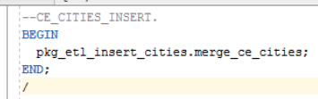

The result of insert:

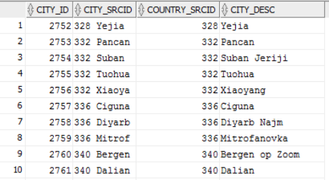

**CE_SELLERS:**

CREATE OR REPLACE PACKAGE pkg_etl_insert_sellers

AUTHID CURRENT_USER

AS

PROCEDURE merge_ce_sellers;

END pkg_etl_insert_sellers;

/

CREATE OR REPLACE PACKAGE BODY pkg_etl_insert_sellers

AS

PROCEDURE merge_ce_sellers

IS

BEGIN

MERGE INTO bl_3nf.ce_sellers t USING

( SELECT seller_id,

first_name,

last_name,

age,

email,

phone,

address,

city_id,

start_dt,

end_dt,

is_active

FROM cls_sellers

MINUS

SELECT

seller_srcid AS seller_id,

first_name,

last_name,

age,

email,

phone,

address,

city_srcid AS city_id,

start_dt,

end_dt,

is_active

FROM bl_3nf.ce_sellers

) c ON ( c.seller_id = t.seller_srcid

AND c.first_name = t.first_name

AND c.last_name = t.last_name

AND t.age = c.age

AND c.email = t.email

AND c.phone = t.phone

)

WHEN MATCHED THEN

UPDATE SET

t.end_dt = c.end_dt,

t.is_active = c.is_active

WHEN NOT matched THEN

INSERT

(

seller_id,

seller_srcid,

first_name,

last_name,

age,

email,

phone,

address,

city_srcid,

start_dt,

end_dt,

is_active

)

VALUES

(

bl_3nf.ce_sellers_seq.NEXTVAL,

c.seller_id,

c.first_name,

c.last_name,

c.age,

c.email,

c.phone,

c.address,

c.city_id,

c.start_dt,

c.end_dt,

c.is_active

) ;

COMMIT;

EXCEPTION

WHEN OTHERS THEN

RAISE;

END merge_ce_sellers;

END pkg_etl_insert_sellers;

/

Implementation of the pkg_etl_insert_sellers:

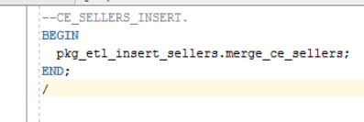

The result of insert:

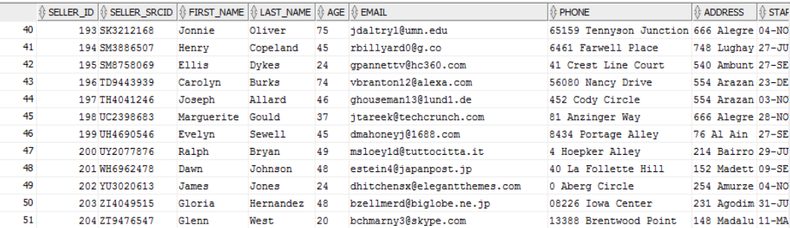

**CE_CUSTOMERS:**

CREATE OR REPLACE PACKAGE pkg_etl_insert_customers

AUTHID CURRENT_USER

AS

PROCEDURE merge_ce_customers;

END pkg_etl_insert_customers;

/

CREATE OR REPLACE PACKAGE BODY pkg_etl_insert_customers

AS

PROCEDURE merge_ce_customers

IS

BEGIN

MERGE INTO bl_3nf.ce_customers t USING

( SELECT customer_id,

first_name,

last_name,

age,

email,

phone,

address,

city_id,

start_dt,

end_dt,

is_active

FROM cls_customers

MINUS

SELECT customer_srcid AS customer_id,

first_name,

last_name,

age,

email,

phone,

address,

city_srcid AS city_id,

start_dt,

end_dt,

is_active

FROM bl_3nf.ce_customers

) c ON ( c.customer_id = t.customer_srcid

AND c.first_name = t.first_name

AND c.last_name = t.last_name

AND c.age = t.age

AND c.email = t.email

AND c.phone = t.phone

AND c.address = t.address

AND t.city_srcid = c.city_id

AND c.start_dt = t.start_dt)

WHEN MATCHED THEN

UPDATE SET

t.end_dt = c.end_dt,

t.is_active = c.is_active

WHEN NOT matched THEN

INSERT

(

customer_id,

customer_srcid,

first_name,

last_name,

age,

email,

phone,

address,

city_srcid,

start_dt,

end_dt,

is_active

)

VALUES

(

bl_3nf.ce_customers_seq.NEXTVAL,

c.customer_id,

c.first_name,

c.last_name,

c.age,

c.email,

c.phone,

c.address,

c.city_id,

c.start_dt,

c.end_dt,

'TRUE'

) ;

COMMIT;

EXCEPTION

WHEN OTHERS THEN

RAISE;

END merge_ce_customers;

END pkg_etl_insert_customers;

/

Implementation of the pkg_etl_insert_customers:

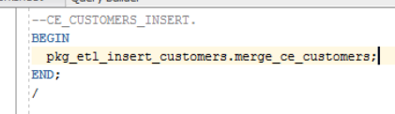

The result of insert:

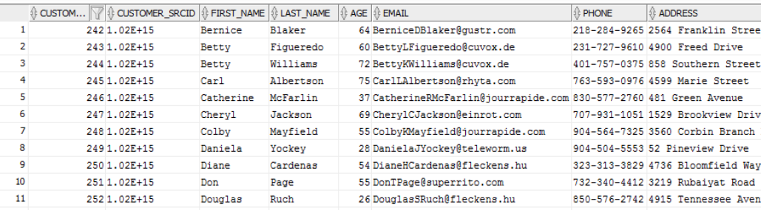

**CE_CATEGORIES:**

CREATE OR REPLACE PACKAGE pkg_etl_insert_categories

AUTHID CURRENT_USER

AS

PROCEDURE merge_ce_categories;

END pkg_etl_insert_categories;

/

CREATE OR REPLACE PACKAGE BODY pkg_etl_insert_categories

AS

PROCEDURE merge_ce_categories

IS

BEGIN

MERGE INTO bl_3nf.ce_categories t USING

( SELECT category_id,

category_name,

start_dt AS update_dt

FROM cls_categories

MINUS

SELECT category_srcid AS category_id,

category_name,

update_dt

FROM bl_3nf.ce_categories

) c ON (c.category_name = t.category_name

AND c.category_id = t.category_srcid

)

WHEN MATCHED THEN

UPDATE SET

t.update_dt = SYSDATE

WHEN NOT matched THEN

INSERT

(

category_id,

category_srcid,

category_name,

update_dt

)

VALUES

(

bl_3nf.ce_categories_seq.NEXTVAL,

c.category_id,

c.category_name,

SYSDATE

) ;

COMMIT;

EXCEPTION

WHEN OTHERS THEN

RAISE;

END merge_ce_categories;

END pkg_etl_insert_categories;

/

Implementation of the pkg_etl_insert_categories:

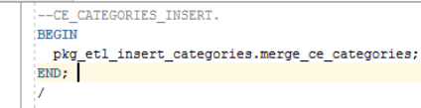

The result of insert:

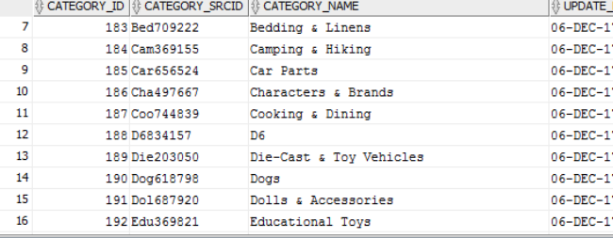

**CE_PRODUCT_TYPES:**

CREATE OR REPLACE PACKAGE pkg_etl_insert_product_types

AUTHID CURRENT_USER

AS

PROCEDURE merge_ce_product_types;

END pkg_etl_insert_product_types;

/

CREATE OR REPLACE PACKAGE BODY pkg_etl_insert_product_types

AS

PROCEDURE merge_ce_product_types

IS

BEGIN

MERGE INTO bl_3nf.ce_product_types t USING

( SELECT product_type_id,

product_type_name,

category_id,

start_dt AS update_dt

FROM cls_product_types

MINUS

SELECT product_type_srcid AS product_type_id,

product_type_name AS product_type_name,

category_srcid AS category_id,

update_dt

FROM bl_3nf.ce_product_types

) c ON ( c.product_type_name = t.product_type_name

AND t.product_type_srcid = c.product_type_id

AND t.category_srcid = c.category_id

)

WHEN MATCHED THEN

UPDATE SET

t.update_dt = SYSDATE

WHEN NOT matched THEN

INSERT

(

product_type_id,

product_type_srcid,

product_type_name,

category_srcid,

update_dt

)

VALUES

(

bl_3nf.ce_product_types_seq.NEXTVAL,

c.product_type_id,

c.product_type_name,

c.category_id,

SYSDATE

) ;

COMMIT;

EXCEPTION

WHEN OTHERS THEN

RAISE;

END merge_ce_product_types;

END pkg_etl_insert_product_types;

/

Implementation of the pkg_etl_insert_product_types:

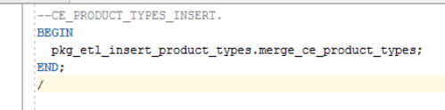

The result of insert:

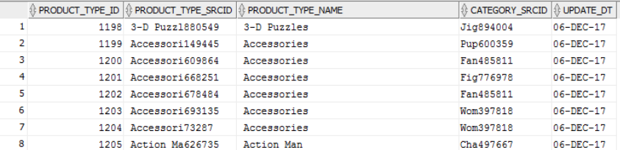

**CE_MANUFACTURERS:**

--PKG_INSERT_MANUFACTURERS

CREATE OR REPLACE PACKAGE pkg_etl_insert_manufacturers

AUTHID CURRENT_USER

AS

PROCEDURE merge_ce_manufacturers;

END pkg_etl_insert_manufacturers;

/

CREATE OR REPLACE PACKAGE BODY pkg_etl_insert_manufacturers

AS

PROCEDURE merge_ce_manufacturers

IS

BEGIN

MERGE INTO bl_3nf.ce_manufacturers t USING

( SELECT manufacturer_id,

manufacturer_code,

manufacturer_name,

phone,

address,

city AS city_srcid,

insert_dt,

update_dt

FROM cls_manufacturers

MINUS

SELECT manufacturer_srcid AS manufacturer_id,

manufacturer_code,

manufacturer_name,

phone,

address,

city_srcid,

insert_dt,

update_dt

FROM bl_3nf.ce_manufacturers

) c ON ( c.manufacturer_id = t.manufacturer_srcid

AND t.manufacturer_name = c.manufacturer_name

AND t.manufacturer_code = c.manufacturer_code

AND t.phone = c.phone

AND t.address = c.address

AND t.city_srcid = c.city_srcid

AND c.insert_dt = t.insert_dt )

WHEN matched THEN

UPDATE SET

t.update_dt = c.update_dt

WHEN NOT matched THEN

INSERT

(

manufacturer_id,

manufacturer_srcid,

manufacturer_code,

manufacturer_name,

phone,

address,

city_srcid,

insert_dt,

update_dt

)

VALUES

(

bl_3nf.ce_manufacturers_seq.NEXTVAL,

c.manufacturer_id,

c.manufacturer_code,

c.manufacturer_name,

c.phone,

c.address,

c.city_srcid,

c.insert_dt,

SYSDATE

) ;

COMMIT;

EXCEPTION

WHEN OTHERS THEN

RAISE;

END merge_ce_manufacturers;

END pkg_etl_insert_manufacturers;

/

Implementation of the pkg_etl_insert_manufacturers:

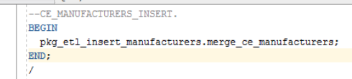

The result of insert:

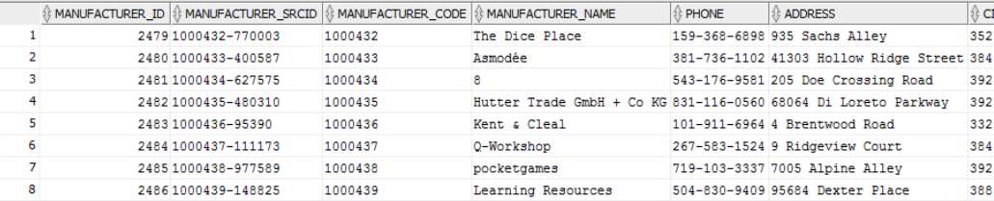

**CE_PRODUCTS:**

CREATE OR REPLACE PACKAGE pkg_etl_insert_products

AUTHID CURRENT_USER

AS

PROCEDURE merge_ce_products;

END pkg_etl_insert_products;

/

CREATE OR REPLACE PACKAGE BODY pkg_etl_insert_products

AS

PROCEDURE merge_ce_products

IS

BEGIN

MERGE INTO bl_3nf.ce_products t USING

( SELECT product_id,

product_name,

product_type_id,

start_dt,

end_dt,

is_active

FROM cls_products

MINUS

SELECT product_srcid AS product_id,

product_name,

product_type_srcid AS product_type_id,

start_dt,

end_dt,

is_active

FROM bl_3nf.ce_products

) c ON ( t.product_srcid = c.product_id

AND c.product_name = t.product_name

AND t.product_type_srcid = c.product_type_id

AND c.start_dt = t.start_dt

)

WHEN MATCHED THEN

UPDATE SET

t.end_dt = c.end_dt,

t.is_active = c.is_active

WHEN NOT matched THEN

INSERT

(

product_id,

product_srcid,

product_name,

product_type_srcid,

start_dt,

end_dt,

is_active

)

VALUES

(

bl_3nf.ce_products_seq.NEXTVAL,

c.product_id,

c.product_name,

c.product_type_id,

c.start_dt,

c.end_dt,

c.is_active

) ;

COMMIT;

EXCEPTION

WHEN OTHERS THEN

RAISE;

END merge_ce_products;

END pkg_etl_insert_products;

/

Implementation of the pkg_etl_insert_manufacturers:

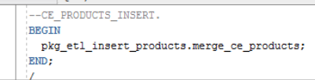

The result of insert:

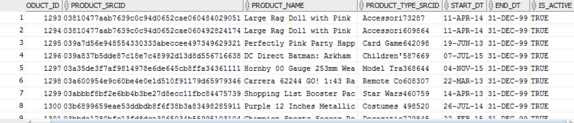

**CE_PRODUCT_INFO:**

* **Use Explicit Cursor (One or more procedures).**

Loading data from BL_CL Layer by means of Explicit Cursor was made on the table that contains information about payment methods.

PROCEDURE insert_table_payment_methods

IS

CURSOR my_cursor

IS

SELECT payment_method_id,

payment_method_name AS payment_method,

start_dt,

end_dt,

is_active

FROM wrk_payment_methods

WHERE payment_method_name IS NOT NULL

AND start_dt IS NOT NULL;

pm_my_cursor cls_payment_methods%rowtype;

BEGIN

EXECUTE IMMEDIATE 'TRUNCATE TABLE cls_payment_methods';

OPEN my_cursor;

LOOP

FETCH my_cursor INTO pm_my_cursor;

IF my_cursor%found THEN

INSERT

INTO cls_payment_methods

(

payment_method_id,

payment_method,

start_dt,

end_dt,

is_active

)

VALUES

(

pm_emp_cursor.payment_method_id,

pm_emp_cursor.payment_method,

pm_emp_cursor.start_dt,

pm_emp_cursor.end_dt,

pm_emp_cursor.is_active

) ;

END IF;

EXIT

WHEN my_cursor%notfound;

END LOOP;

COMMIT;

CLOSE my_cursor;

COMMIT;

EXCEPTION

WHEN OTHERS THEN

RAISE;

END insert_cls_payment_methods;

Packages:

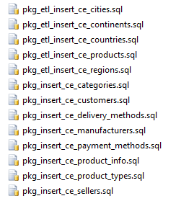

* **Use Implicit Cursor (One or more procedures).**

Loading data from BL_CL Layer by means of Explicit Cursor was made on the table that contains information about payment methods. The examples of Implicit Cursors are INSERT, UPDATE or SELECT.

PROCEDURE insert_table_payment_methods

IS

BEGIN

EXECUTE IMMEDIATE ('TRUNCATE TABLE cls_payment_methods');

INSERT INTO cls_payment_methods (

payment_method_id,

payment_method,

start_dt,

end_dt,

is_active

)

SELECT SUBSTR(payment_method,1,5) || '-' || TRUNC(dbms_random.value(1,1000000)) AS payment_method_id,

payment_method_name AS payment_method,

start_dt,

end_dt,

is_active

FROM wrk_payment_methods;

COMMIT;

EXCEPTION

WHEN OTHERS THEN

RAISE;

END insert_table_payment_methods;

* **Use Merge (One or more procedures).**

Loading data about regions from BL_CL Layer to BL_3NF Layer by means of MERGE:

--PKG_INSERT_REGIONS.

CREATE OR REPLACE PACKAGE pkg_etl_insert_regions

AUTHID CURRENT_USER

AS

PROCEDURE merge_ce_regions;

END pkg_etl_insert_regions;

/

CREATE OR REPLACE PACKAGE BODY pkg_etl_insert_regions

AS

PROCEDURE merge_ce_regions

IS

BEGIN

MERGE INTO bl_3nf.ce_regions t USING

( SELECT continent_id,

region_id,

region_desc

FROM cls_regions

MINUS

SELECT continent_srcid,

region_srcid AS region_id,

region_desc

FROM bl_3nf.ce_regions

) c ON ( c.region_id = t.region_srcid

AND c.continent_id = t.continent_srcid

AND c.region_desc = t.region_desc)

WHEN NOT matched THEN

INSERT

(

region_ID ,

region_srcid ,

continent_srcid,

region_desc

)

VALUES

(

bl_3nf.ce_regions_seq.NEXTVAL,

c.region_id,

c.continent_id,

c.region_desc

) ;

COMMIT;

EXCEPTION

WHEN OTHERS THEN

RAISE;

END merge_ce_regions;

END pkg_etl_insert_regions;